**Challenge 15**

[www.pythonchallenge.com/pc/return/mozart.html](http://www.pythonchallenge.com/pc/return/mozart.html)

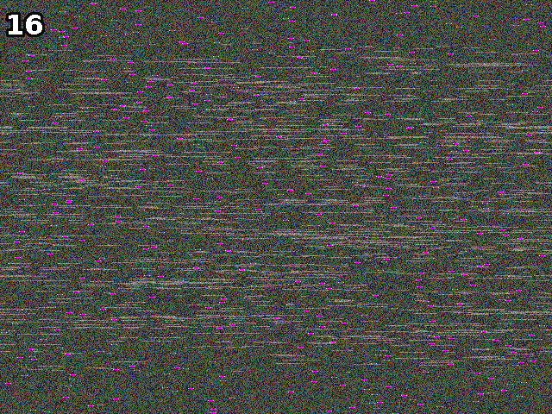

This has to be a manipulate the picture thing. Page title is ‘let me get this straight’ and picture is ‘mozart.gif.’

Looking closely there is a pink bar on every line of the image.

I had some trouble handling the image in python. Ended up putting it into PCPaint and saving it as a png file. Then I could use cv2.imread.

Then it’s a matter of finding the pink bars and lining them all up on a new image with the pinks in the middle.

Both sides say ‘romance’. Yes, did this one all by myself. On to challenge 16.

